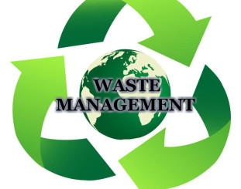

INTERVIEW REPORT

**AT**

**CARENTRA N.V.**

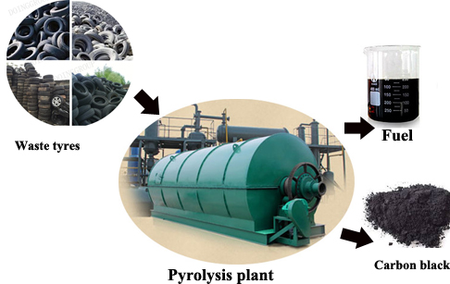

Kayvan Fletcher Professors: Christie Mettes

Melissa Garcia Hernandez Tony Sevold

**INTERVIEW REPORT**

An interview was conducted at Carentra N.V. (Aruba waste tire recycling pyrolysis plant), on waste management in Aruba. Director and CEO of Carentra N.V., Mr. Jamal Mahawatkhan was unable to conduct the interview with us, however, Plant Manager, Mr. Hemmo Kreekel, assisted us in the interview. Mr. Kreekel gave us an insight into the company. He went on to say that Carentra was established approximately 3.5 years ago by Mr. Mahawatkhan, and is the only tire recycling pyrolysis plant on the island, which, recycles mainly non-reusable vehicle tires and used engine and hydraulic oil. The company also collects old vehicle batteries and aluminum cans from the community and Ecogas Free Zone N.V., which, is then shipped abroad for further processing. Carentra’s goal is to stop pollution, caused by burning tires, and aid in environmental sustainability. In order to carry out this goal, the company collects tires (without fee), processes them until it becomes gas, the gas is then compensated into burning oil, to produce; diesel fuel, gasoline, light fuel oil and jet fuel. The carbon black obtained from the tires are reused in inks cartridges. Mr. Kreekel believes that this process is most beneficial to the environment, consumers and their company, because it recycles tires 100 %, therefore, no waste goes to landfill. Moreover, the final product is sold to various companies on the island, at an attractable price, making this a win-win situation for both parties. Furthermore, his desires for the future of the company is focused on cleaning up the environment, creating and advertising their fuel products, with the intent that the Aruban community will recognize the value and quality of a homemade product. After the overview of the company; Mr. Kreekel expressed his personal and professional impressions of waste management in Aruba. He believes that Aruba is heading into the right direction in terms of waste management, however, there are still room for improvements, where people need to be educated and aware of the issues behind this problem. Furthermore, he suggests that government should be more involved in this process and aid financially, because recycling is an important aspect and requires a lot of energy, time and money. Without their input, many improvements will not manifest in the future, therefore, government should implement rules and regulations, where fees are charged for the disposal of waste to balance the issue. The cost can be put towards reducing electricity or fuel expenses. Moreover, government should decrease the importation and exportation fees, which will allow more companies to export vehicle batteries and aluminum, since Aruba does not have a refinery to produce batteries or melt steel and aluminum. These fees should be taken into consideration and be reduced. On a more optimistic note, Mr. Kreekel stated that funds for recycling are being provided by private companies, who are doing their best to aid in environmental sustainability. He especially admires Ecogas services, for converting reusable disposals into gas, and providing it to WEB N.V. to operate their machines. Aruba is beginning to rely on their own resources, however, it will take another 10 years to be 100 % sustainable. Of course, there are obstacles that may hinder the desired future of waste management for Aruba, like the failure of our government to enforce recycling laws, aid financially and the lack of interest from people who continue to burn tires, use plastic sacks and litter. Nevertheless, the market for improved waste management in Aruba will continue to grow, more people, other than recycle companies, nature lovers and researches will understand the hazards of not recycling and pay for better waste management.

**INTERVIEW QUESTIONNAIRE**

Date: November 17, 2017 Place: Carentra N.V. Time: 10.30 am

Interviewers: Kayvan Fletcher, Melissa Garcia Hernandez and Alain Gede

**Introduction questions:**

* *Tell us something about yourself, mainly;*

(**name**, **years of experience in current field**, **and** **function at Carentra**).

* *Tell us a little about your company:*
* When was it established?
* By whom?
* What does Carentra do?
* What are the standard recycling requirements?
* How are tires recycled (Process)?
* Do people bring tires in or does Carentra collect them?
* Does anyone or place recycle tires other than Carentra?
* What inspires you to recycle tires and what goals do you wish to achieve?

**Edu questions:**

The following questions are general questions and are not directed specifically to the recycling of tires, therefore, we structured the questions based on our topic ‘waste management’ and ‘Carentra’s services’. We would like your view on waste management in Aruba and tire recycling. But before we begin, we will give you a brief summary of the situation of waste on the island.

|  |
| --- |
| *The disposal of garbage on Aruba is a growing concern, because there is limited space for landfills. This is evident at the Parkiettenbos dump. Many people are unaware of the damages that may offer from not taken cautious measurements to recycle. Even though, a growing number of private companies in Aruba also recycle and ship paper, newspapers, cartons, and aluminum, as well as printer and toner* *cartridges, to buyers abroad. The problem of waste management on the island has made little progress. As a result, the government has established a sustainable plan for 2020 to turn waste into energy, and illuminate this issue.*  *What is your opinion on the following questions?* |

1. **Personal and professional impressions of waste management in Aruba**

* What is your opinion on how Aruba deals with its waste?

(personal question on waste)

* What are Carentra’s point of view on waste management on Aruba? (professional impression)
* What do you think about tire recycling on Aruba (Is it important or an issue?)
* What happens if tires are not recycled?
* How does Aruba deal with tire recycling? **Please elaborate**

(is it ignored; is it seen as a problem; is it underestimated)

1. **Desired future of waste management in Aruba**

* How do you see Aruba dealing with waste management in the future?

Will the government reach its goal on waste management in 2020?

Are you optimistic/pessimistic about the future of waste management and, Why?

* How would you want waste management to be in the future, for Aruba?
* What are your desires for the future of tire recycling?
* How do you see the recycling of tires in the future? **Elaborate your answer**

(improved or ignored)

1. **Obstacles seen in getting to this desired future scenario**

* What may hinder the desired future of waste management on Aruba?
* What would you say are possible obstacles that tire recycling might encounter in the future?

1. **Market for improved waste management in Aruba**

* Who would pay for better waste management in Aruba (e.g. recycling) and why would they?
* Why wouldn’t they?

The End!!!